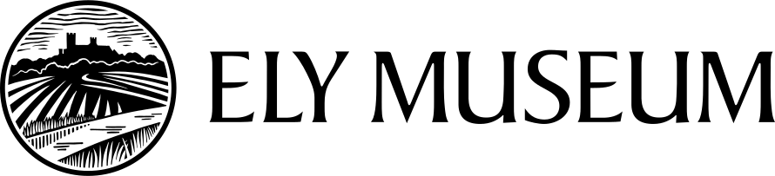

Paranormal Investigation Bookings Terms & Conditions

Please read these terms and conditions thoroughly before sending in a booking form.

Charges

Standard package: 7pm-12am incl. opening up fee = £400

Flexible options:
5pm-10pm - £60 per hour
10pm-12am - £90 per hour
(subject to opening up fee of £40)

The timings of the booking must take into account set up and clearing up time.

A non-returnable £50 deposit is required at the time of booking.

Cancellation charges

- More than 14 days notice: no charge
- 14-2 days notice: 25% of invoice payable
- Less than 2 days notice: 100% of invoice payable
- Rescheduled bookings are available subject to availability

Payment

An invoice can be provided. Bank transfer is preferred, cash by agreement.
Payment must be made within 30 days of the invoice date. No further bookings can be made until payment has been received in full.

Refreshments
Self-service kitchenette facilities are available for use and the hirer may bring their own supplies.
Tea, coffee, milk and biscuits can be provided by the museum @£2.50 per person and must be booked 3 days in advance.
Users are required to leave the kitchenette and room clean and tidy with all crockery washed and put away.
Refreshments may not be taken into the main museum building.
The hirer will undertake to provide any licence required for the serving of alcohol.
General

- Maximum group number 40 people (including group members and paying guests).

- Some museum objects are on open display. These should not be touched or sat upon. If an object can be touched, it will say so clearly, otherwise please do not touch.

- The displays and building should be treated with respect.

- Emergency circulation lights need to be kept on at all times. Extra care should be taken in the gaol cell where light levels are low and the floor is uneven.

- The hirer is liable for the behaviour and safety of attendees at their function. Any accidents should be reported to Ely Museum and recorded in their accident book.

- Hirers are expected to hold appropriate insurance for their own needs. Public liability certificates should be sent to the museum with a risk assessment at the time of booking.

- The Hirer shall be liable for and indemnify Ely Museum against all liabilities, damages, costs, losses, claims, expenses, demands or proceedings whatsoever and however arising in respect of the period of hire or on consequence thereof.

- Ely Museum is a no smoking site. No candles, burning or flames allowed.

- No animals, other than assistance dogs.

- All hirers will familiarise themselves with and observe fire regulations.

- No decorations or fixtures to be attached to the walls.

- All breakages must be paid for. Damage to the equipment, fixtures and fittings of the building will be charged according to the cost of repair or replacement.

- There is no museum car park, however the council car park next to the museum is available for public use in the evening.

- There is level access to the Aedwen Room from the street, by way of a lift. There is an accessible toilet on the ground floor. Further access details can be found on our website.

Wi-Fi is available Network:Museums_Guest Pasword: Cathedral2020

